
Tertiary Infotech Academy Pte Ltd
UEN: 201200696W
LEARNER GUIDE
For
Certified Lean Six Sigma Yellow Belt (CLSSYB) Training
TGS Ref No: TGS-2025053922
Conducted by
Tertiary Infotech Academy Pte Ltd
UEN: 201200696W
Version 3.0

DOCUMENT VERSION CONTROL RECORD
Version Number | Effective Date of Release | Summary of Included Changes | Author
1.0 | 9 July 2026 | Initial CLSSYB courseware aligned to the TGS-2025053922 lab set | Tertiary Infotech Academy Pte Ltd
2.0 | 9 July 2026 | Updated slide visuals and admin pages to match Tertiary courseware examples | Tertiary Infotech Academy Pte Ltd
3.0 | 9 July 2026 | Enhanced LP/LG formatting and added CLSSYB visual learning aids | Tertiary Infotech Academy Pte Ltd

TABLE OF CONTENTS
Update table of contents
Right-click and choose Update Field, or press F9, to build the table of contents.

Welcome
Welcome! This guide takes you step-by-step through every hands-on lab in the WSQ course Certified Lean Six Sigma Yellow Belt (CLSSYB) Training (Course Code: TGS-2025053922). You will build one continuous improvement package for the Contoso Service Desk case study, moving from Yellow Belt role clarity to control planning, A3 handover and certification readiness.
Course flow at a glance
Day 1 builds the improvement package from Yellow Belt role, VOC and SIPOC through PDCA, DMAIC Define, measurement, analysis, root cause and countermeasures. Day 2 completes control planning, A3 handover, review and assessment readiness.

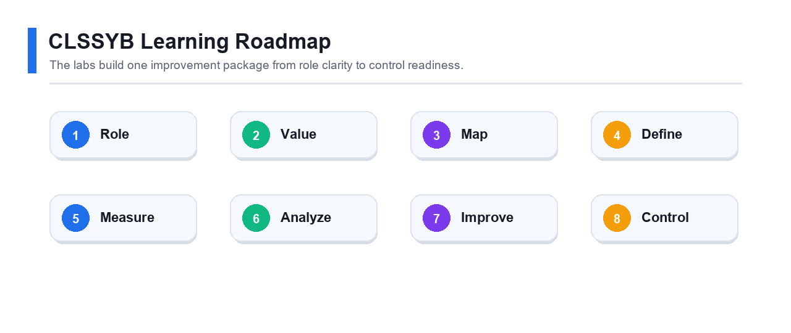
Course roadmap: each lab adds one piece to the final Yellow Belt improvement package.

How to Use This Guide
- Complete the labs in order because each lab adds to the same improvement package.
- For each lab, read the objective and scenario before completing the step-by-step tasks.
- Submit the stated deliverables and use the checkpoint questions to test understanding.

Lab Index
Lab | Primary skill | Title
1 | Yellow Belt role and readiness | Yellow Belt Role, Certification Paths, and Improvement Scenario
2 | Lean Six Sigma foundations | Lean, Six Sigma, Waste, Voice of Customer, and Value
3 | SIPOC and process mapping | SIPOC, Process Mapping, Handoffs, and Yellow Belt SME Support
4 | PDCA project charter | PDCA Small Improvement Project Charter
5 | DMAIC Define support | DMAIC Overview, Problem Statement, Scope, and Stakeholders
6 | Measurement planning | Data Collection, KPIs, Check Sheets, and Basic Metrics
7 | Basic analysis and variation | Pareto, Run Charts, Variation, Yield, DPU, and DPMO
8 | Root cause support | Root Cause Analysis with 5 Whys, Fishbone, and Evidence
9 | Improve tools and kaizen | Countermeasures, 5S, Mistake Proofing, Standard Work, and Kaizen
10 | Control and certification readiness | Control Plan, A3 Summary, Handover, and Certification Readiness

Lab 1: Yellow Belt Role, Certification Paths, and Improvement Scenario
Field | Details
Primary skill | Yellow Belt role and readiness
Source lab file | labs/lab-01-yellow-belt-role-certification-scenario.md

Objective
Explain the Lean Six Sigma Yellow Belt role, compare certification path expectations, and choose a simple improvement scenario.

Scenario
Contoso Service Desk wants to reduce delays in assigning support tickets. You are not leading a major Green Belt project, but you are supporting the team by mapping the process, gathering data, and testing a small PDCA improvement.
What you will produce
Submit role table, certification path comparison, selected scenario, and readiness checklist.

Step-by-Step Lab Guide

Step 1 - Define the Yellow Belt role
Responsibility | Yellow Belt contribution

Complete the blank cells with your own analysis before moving to the next step.

Step 2 - Compare certification pathways
Path | Best for | Preparation need
Standard comprehensive exam
Self-paced chapter exams

Complete the blank cells with your own analysis before moving to the next step.

Step 3 - Select improvement scenario
Choose one:
- Contoso Service Desk ticket assignment delay
- Real workplace process approved by trainer
Write:
- Process name
- Customer
- Pain point
- Expected benefit
- Data available

Step 4 - Create readiness checklist
Topic | Current confidence 1-5 | Study action

Complete the blank cells with your own analysis before moving to the next step.

Deliverable
Submit role table, certification path comparison, selected scenario, and readiness checklist.

Checkpoint Questions
- Why does a Yellow Belt usually support rather than lead major projects?
- Why is process mapping an important Yellow Belt contribution?
- What makes your chosen scenario suitable for a small improvement?

Lab 2: Lean, Six Sigma, Waste, Voice of Customer, and Value
Field | Details
Primary skill | Lean Six Sigma foundations
Source lab file | labs/lab-02-lean-six-sigma-waste-voc-value.md

Objective
Identify customer value, voice of customer, waste, defects, and variation in a simple process.

Scenario
Employees complain that IT support tickets are slow and status updates are unclear. The team needs to understand what customers value before choosing improvements.

The CLSSYB labs build one continuous improvement package.
What you will produce
Submit VOC table, value-added table, waste walk table, and defect/variation notes.

Step-by-Step Lab Guide

Step 1 - Capture voice of customer
Customer statement | Need | CTQ requirement

Complete the blank cells with your own analysis before moving to the next step.

Step 2 - Identify value-added work
Activity | Value-added, business-value, or non-value-added | Reason

Complete the blank cells with your own analysis before moving to the next step.

Step 3 - Conduct a waste walk
Find examples of the eight wastes:
- Defects
- Overproduction
- Waiting
- Non-utilized talent
- Transportation
- Inventory
- Motion
- Extra processing

Step 4 - Connect Six Sigma to defects and variation
Define:
- What is a defect in this process?
- What is an opportunity for defect?
- What variation is visible?
- What data would prove the issue?

Deliverable
Submit VOC table, value-added table, waste walk table, and defect/variation notes.

Checkpoint Questions
- What is the difference between waste and a defect?
- Why should customer needs be translated into CTQs?
- Which waste appears most often in your scenario?

Lab 3: SIPOC, Process Mapping, Handoffs, and Yellow Belt SME Support
Field | Details
Primary skill | SIPOC and process mapping
Source lab file | labs/lab-03-sipoc-process-map-handoffs.md

Objective
Create a SIPOC and process map that helps an improvement team understand boundaries, handoffs, inputs, outputs, and customers.

Scenario
The service desk manager asks you to map the ticket assignment process so a Green Belt can decide whether a larger DMAIC project is needed.
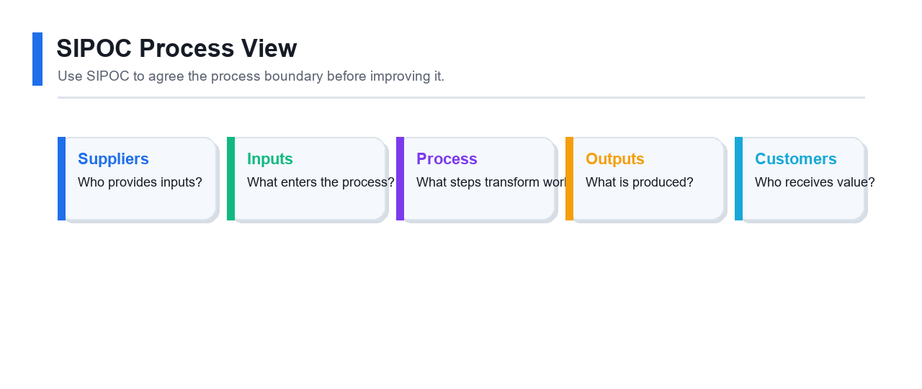
SIPOC clarifies the process boundary before detailed mapping.
What you will produce
Submit SIPOC, detailed process map, pain point notes, and SME notes.

Step-by-Step Lab Guide

Step 1 - Build SIPOC
Suppliers | Inputs | Process | Outputs | Customers

Complete the blank cells with your own analysis before moving to the next step.

Step 2 - Create detailed process map
Step | Actor | Activity | System | Handoff

Complete the blank cells with your own analysis before moving to the next step.

Step 3 - Mark pain points
On the process map, identify:
- Waiting points
- Rework loops
- Missing decision rules
- Duplicate entry
- Unclear ownership

Step 4 - Prepare SME notes
Write notes a Yellow Belt SME would bring to a project team:
- What actually happens
- Where work gets stuck
- Which rules are informal
- Which data fields are unreliable
- Which people should be interviewed

Deliverable
Submit SIPOC, detailed process map, pain point notes, and SME notes.

Checkpoint Questions
- Why is SIPOC useful before detailed mapping?
- What is a handoff risk?
- How can a Yellow Belt help a project leader without owning the whole project?

Lab 4: PDCA Small Improvement Project Charter
Field | Details
Primary skill | PDCA project charter
Source lab file | labs/lab-04-pdca-small-improvement-charter.md

Objective
Create a PDCA charter for a small improvement that a Yellow Belt could support or run under guidance.

Scenario
The service desk wants to test whether a new ticket triage checklist reduces assignment delay within two weeks.
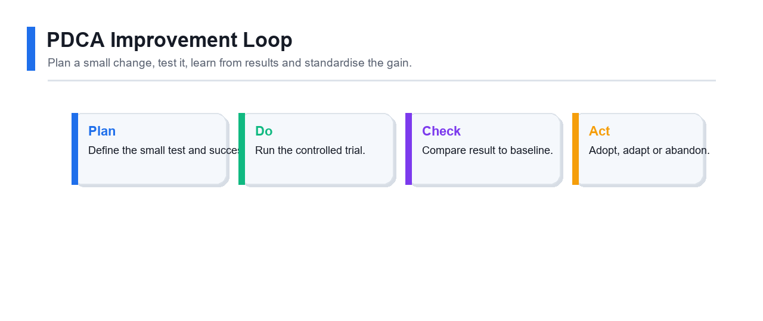
PDCA keeps the small improvement test controlled and reversible.
What you will produce
Submit PDCA table, problem statement, goal statement, scope, risk table, and test plan.

Step-by-Step Lab Guide

Step 1 - Define PDCA cycle
PDCA phase | Action for this scenario
Plan
Do
Check
Act

Complete the blank cells with your own analysis before moving to the next step.

Step 2 - Write problem and goal statements
Use this format:
`text
Problem: From <date range>, <process> experienced <measurable issue>, causing <customer/business impact>.
Goal: Reduce/increase <metric> from <baseline> to <target> by <date>.
`

Step 3 - Define scope
In scope | Out of scope

Complete the blank cells with your own analysis before moving to the next step.

Step 4 - Identify risks and assumptions
Risk or assumption | Impact | Response

Complete the blank cells with your own analysis before moving to the next step.

Step 5 - Plan the test
Define:
- Test change
- Pilot team
- Start and end date
- Data to collect
- Review meeting
- Decision rule to adopt, adapt, or abandon

Deliverable
Submit PDCA table, problem statement, goal statement, scope, risk table, and test plan.

Checkpoint Questions
- Why is PDCA suitable for small improvements?
- What makes a goal statement measurable?
- What decision will you make after the Check phase?

Lab 5: DMAIC Overview, Problem Statement, Scope, and Stakeholders
Field | Details
Primary skill | DMAIC Define support
Source lab file | labs/lab-05-dmaic-define-scope-stakeholders.md

Objective
Support the Define phase of a DMAIC project by clarifying the problem, scope, stakeholders, customers, and expected benefits.

Scenario
The PDCA pilot shows promise, but management may escalate the issue to a larger DMAIC project. Your Yellow Belt task is to prepare clear Define information.
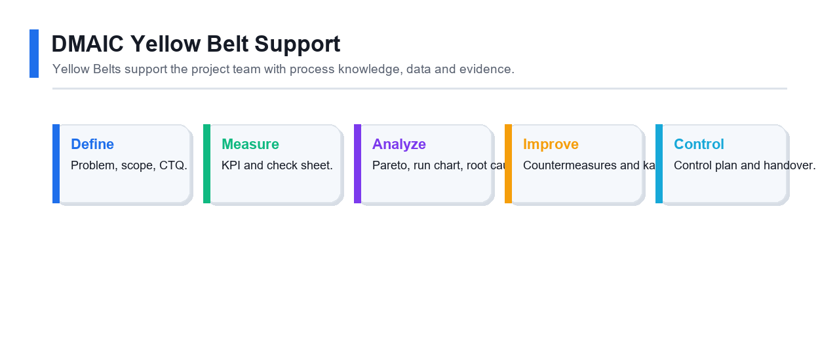
DMAIC connects Define work to later Measure, Analyze, Improve and Control steps.
What you will produce
Submit DMAIC summary, refined problem statement, stakeholder table, project boundaries, and benefit notes.

Step-by-Step Lab Guide

Step 1 - Summarize DMAIC
Phase | Purpose | Yellow Belt support
Define
Measure
Analyze
Improve
Control

Complete the blank cells with your own analysis before moving to the next step.

Step 2 - Refine problem statement
Check that your statement includes:
- Process
- Time period
- Measurable problem
- Impact
- No assumed root cause
- No assumed solution

Step 3 - Identify stakeholders
Stakeholder | Role | Interest | Communication need

Complete the blank cells with your own analysis before moving to the next step.

Step 4 - Define project boundaries
Document:
- Start point
- End point
- Included departments
- Excluded departments
- Key assumptions

Step 5 - Estimate benefit
Create benefit notes for:
- Time saved
- Defects reduced
- Waiting reduced
- Customer satisfaction improved
- Staff frustration reduced

Deliverable
Submit DMAIC summary, refined problem statement, stakeholder table, project boundaries, and benefit notes.

Checkpoint Questions
- Why should a problem statement avoid naming a solution?
- Which DMAIC phases can a Yellow Belt support strongly?
- Who must be involved before scope is finalized?

Lab 6: Data Collection, KPIs, Check Sheets, and Basic Metrics
Field | Details
Primary skill | Measurement planning
Source lab file | labs/lab-06-data-collection-kpis-check-sheets.md

Objective
Create a data collection plan with KPIs, operational definitions, check sheets, and basic metric calculations.

Scenario
The service desk team has anecdotal complaints, but improvement decisions need data. You will design a simple measurement plan.
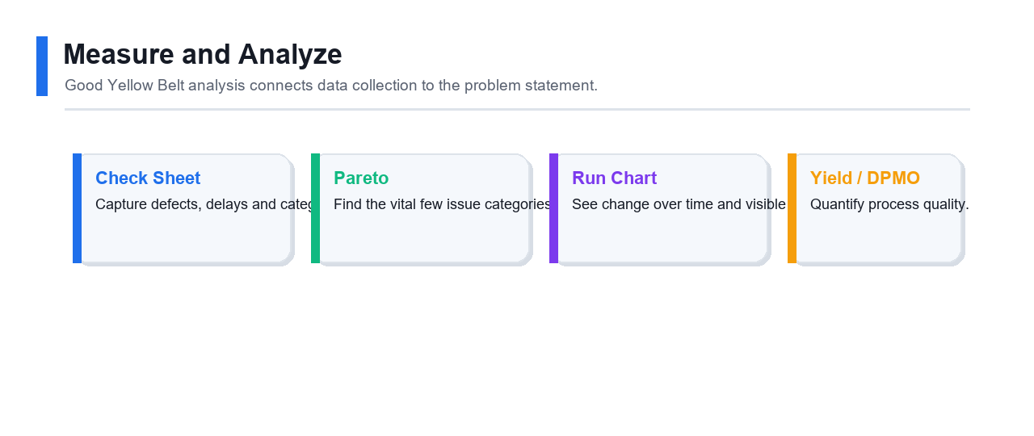
Measurement choices should support analysis, not just reporting.
What you will produce
Submit KPI table, check sheet, defect categories, sampling plan, and basic metric calculations.

Step-by-Step Lab Guide

Step 1 - Define KPIs
KPI | Operational definition | Data source | Frequency

Complete the blank cells with your own analysis before moving to the next step.

Step 2 - Create a check sheet
Design a check sheet with:
- Date
- Ticket ID
- Ticket type
- Assignment time
- Defect category
- Rework required
- Notes

Step 3 - Define defect categories
Create categories:
- Missing information
- Wrong queue
- Delayed assignment
- Duplicate ticket
- Reopened ticket
- Unclear status

Step 4 - Plan sampling
Document:
- Sample size
- Collection period
- Who records data
- How data is checked
- What bias might occur

Step 5 - Calculate basic metrics
Use sample values to calculate:
- Total tickets
- Defect count
- Defect rate
- Average assignment time
- Range of assignment time

Deliverable
Submit KPI table, check sheet, defect categories, sampling plan, and basic metric calculations.

Checkpoint Questions
- Why does an operational definition matter?
- What bias could affect your data?
- Which KPI best reflects the customer pain point?

Lab 7: Pareto, Run Charts, Variation, Yield, DPU, and DPMO
Field | Details
Primary skill | Basic analysis and variation
Source lab file | labs/lab-07-pareto-run-chart-variation-yield.md

Objective
Analyze simple process data using Pareto charts, run charts, variation concepts, yield, DPU, and DPMO.

Scenario
You collected two weeks of service desk data. The team wants to know which defect category matters most and whether assignment time is improving.

Pareto, run chart and yield metrics turn raw counts into improvement evidence.
What you will produce
Submit Pareto table, chart screenshot or notes, run chart, metric calculations, and interpretation notes.

Step-by-Step Lab Guide

Step 1 - Build Pareto table
Defect category | Count | Percent | Cumulative percent

Complete the blank cells with your own analysis before moving to the next step.

Step 2 - Create Pareto chart
Using spreadsheet software:
1. Enter defect categories and counts.
2. Sort descending.
3. Add cumulative percent.
4. Create bar chart for counts.
5. Add cumulative percent line if your tool supports it.

Step 3 - Create run chart
Create a run chart of daily average assignment time.
Record:
- Baseline average
- Highest point
- Lowest point
- Direction of trend
- Any unusual point

Step 4 - Calculate yield, DPU, and DPMO
Use:
`text
Yield = Good Units / Total Units
DPU = Defects / Units
DPMO = (Defects / (Units * Opportunities per Unit)) * 1000000
`

Step 5 - Interpret variation
Write notes:
- What variation is normal?
- What variation needs investigation?
- What data is missing?
- What conclusion should not be made yet?

Deliverable
Submit Pareto table, chart screenshot or notes, run chart, metric calculations, and interpretation notes.

Checkpoint Questions
- What does a Pareto chart help prioritize?
- What does a run chart show over time?
- Why should you avoid overreacting to one data point?

Lab 8: Root Cause Analysis with 5 Whys, Fishbone, and Evidence
Field | Details
Primary skill | Root cause support
Source lab file | labs/lab-08-root-cause-5-whys-fishbone.md

Objective
Support root cause analysis using 5 Whys, fishbone diagram categories, and evidence checks.

Scenario
Pareto analysis shows delayed assignment is the largest defect category. The team asks you to help identify possible causes.
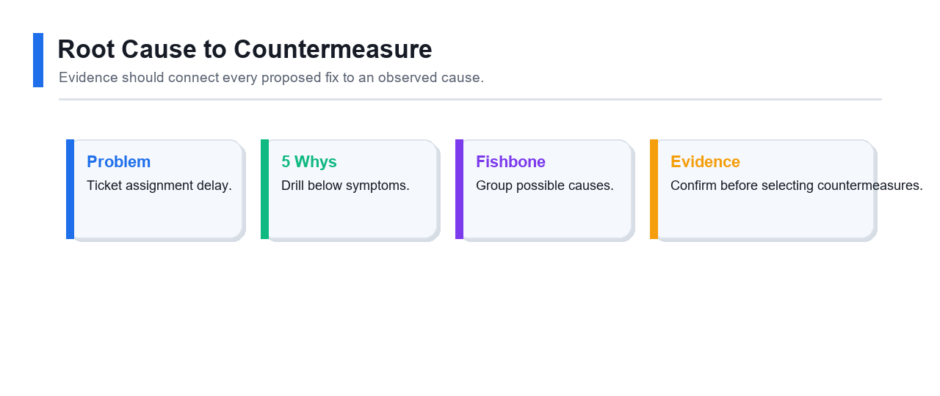
Root cause analysis links symptoms to evidence before countermeasures are chosen.
What you will produce
Submit problem statement, 5 Whys table, fishbone diagram, cause priority table, and validation plan.

Step-by-Step Lab Guide

Step 1 - Write the problem
Use one focused problem:
`text
Ticket assignment is delayed for <percentage> of tickets during <period>, causing <impact>.
`

Step 2 - Complete 5 Whys
Why level | Answer | Evidence needed

Complete the blank cells with your own analysis before moving to the next step.

Step 3 - Create fishbone diagram
Use categories:
- People
- Process
- Policy
- Technology
- Measurement
- Environment
Add possible causes under each.

Step 4 - Prioritize likely causes
Possible cause | Evidence available | Confidence high/medium/low

Complete the blank cells with your own analysis before moving to the next step.

Step 5 - Validate before solution
Write what data, observation, interview, or test would confirm each likely cause.

Deliverable
Submit problem statement, 5 Whys table, fishbone diagram, cause priority table, and validation plan.

Checkpoint Questions
- Why should root cause analysis use evidence?
- What makes a cause actionable?
- Why should the team avoid jumping straight to solutions?

Lab 9: Countermeasures, 5S, Mistake Proofing, Standard Work, and Kaizen
Field | Details
Primary skill | Improve tools and kaizen
Source lab file | labs/lab-09-countermeasures-5s-pokayoke-standard-work.md

Objective
Select practical countermeasures using 5S, mistake proofing, visual management, standard work, and Kaizen planning.

Scenario
Root cause analysis suggests delayed assignments happen because ticket categories are inconsistent and required information is missing. The team wants low-risk countermeasures.

Countermeasures should address confirmed causes rather than symptoms.
What you will produce
Submit countermeasure table, priority scoring, 5S table, mistake-proofing design, and standard work checklist.

Step-by-Step Lab Guide

Step 1 - Generate countermeasures
Root cause | Countermeasure | Expected effect

Complete the blank cells with your own analysis before moving to the next step.

Step 2 - Prioritize countermeasures
Score each idea:
- Impact: 1 to 5
- Effort: 1 to 5
- Risk: 1 to 5
- Priority = impact - effort - risk

Step 3 - Apply 5S thinking
5S | Service desk example
Sort
Set in order
Shine
Standardize
Sustain

Complete the blank cells with your own analysis before moving to the next step.

Step 4 - Design mistake proofing
Choose two mistake-proofing ideas:
- Required fields
- Dropdown categories
- Auto-routing rules
- Warning message
- Checklist before submission

Step 5 - Create standard work
Write a short standard work checklist for ticket triage with owner, timing, and expected output.

Deliverable
Submit countermeasure table, priority scoring, 5S table, mistake-proofing design, and standard work checklist.

Checkpoint Questions
- What is the difference between a countermeasure and a permanent solution?
- How can 5S apply to digital work?
- Why is standard work important after improvement?

Lab 10: Control Plan, A3 Summary, Handover, and Certification Readiness
Field | Details
Primary skill | Control and certification readiness
Source lab file | labs/lab-10-control-plan-a3-certification-readiness.md

Objective
Create a control plan, A3-style improvement summary, handover checklist, and personal certification readiness plan.

Scenario
The PDCA test improved assignment time. The team needs a simple control plan so the gain is sustained and management can decide whether to expand the solution.
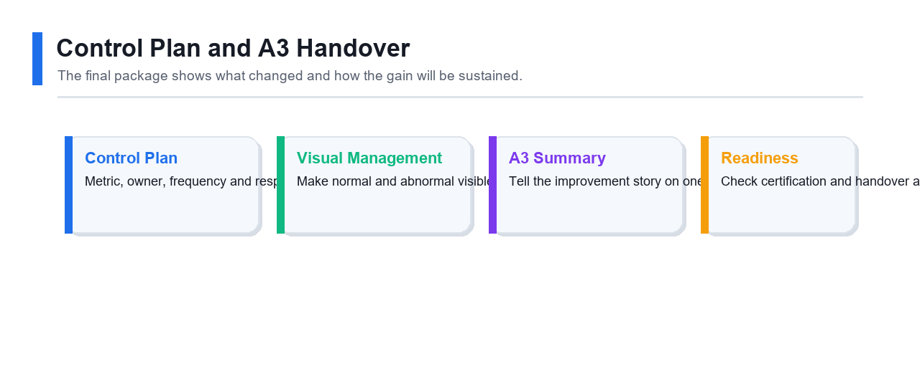
Control planning and A3 handover sustain the improvement after the lab.
What you will produce
Submit control plan, visual management notes, A3 summary, handover checklist, and certification readiness plan.

Step-by-Step Lab Guide

Step 1 - Create control plan
Process step | Metric | Target | Owner | Check frequency | Response plan

Complete the blank cells with your own analysis before moving to the next step.

Step 2 - Define visual management
Choose simple visuals:
- Weekly run chart
- Defect category Pareto
- Status board
- Checklist compliance count
- Escalation trigger list

Step 3 - Write A3 summary
Create sections:
1. Background
2. Current condition
3. Goal
4. Analysis
5. Countermeasures
6. Implementation plan
7. Results
8. Follow-up and control

Step 4 - Prepare handover
Create handover checklist:
- Process owner accepts control plan.
- Standard work is stored.
- KPI report owner is assigned.
- Review cadence is scheduled.
- Open issues are listed.
- Escalation criteria are documented.

Step 5 - Build certification readiness plan
Topic | Confidence 1-5 | Evidence from labs | Next review action

Complete the blank cells with your own analysis before moving to the next step.

Deliverable
Submit control plan, visual management notes, A3 summary, handover checklist, and certification readiness plan.

Checkpoint Questions
- Why does an improvement need a control plan?
- What should happen if a metric falls outside target?
- Which Yellow Belt topic needs your most review?

Tools and Templates

Tools and Templates

References
- CSSC Lean Six Sigma Yellow Belt Certification: https://www.sixsigmacouncil.org/lean-six-sigma-yellow-belt-certification/
- Course registration: https://www.tertiarycourses.com.sg/wsq-certified-lean-six-sigma-yellow-belt-clssyb-training.html

Free tools
- Microsoft Excel, LibreOffice Calc, or Google Sheets
- Draw.io / diagrams.net
- Paper, sticky notes, and whiteboard
- Markdown editor or GitHub web editor

Template list
- Yellow Belt role worksheet
- Waste walk table
- SIPOC table
- Swimlane process map
- PDCA charter
- DMAIC Define worksheet
- Stakeholder map
- Check sheet
- Pareto chart
- Run chart
- 5 Whys worksheet
- Fishbone diagram
- Countermeasure matrix
- 5S audit sheet
- Standard work checklist
- Control plan
- A3 summary

Spreadsheet formulas
```text
Yield = Good Units / Total Units
DPU = Defects / Units
DPMO = (Defects / (Units * Opportunities per Unit)) * 1000000
Percent = Count / Total Count
Cumulative Percent = Running Total / Total Count
```

Learner evidence
Save:
- Tables and worksheets
- Process maps and diagrams
- Spreadsheet calculations
- Screenshots
- A3 summary
- Certification readiness checklist

